Using this template

The following template can be used to help your organization develop a written Distracted Driving policy. This template cannot be used as is—you must customize the template to meet the needs of your organization. We have made this template easier for you to customize by adding visual prompts that identify some areas where your input is needed. These are identified by yellow highlighted, red text in the template. You may also change any of the text in the template to meet your organization’s needs—for example, department names, job titles and listed responsibilities and procedures.

Example:

<COMPANY NAME>
Distracted Driving Policy
becomes
XYZ Company
Distracted Driving Policy

To remove the colored highlighting from your text, left click and drag your mouse over the yellow text and click on the highlighter button from the Font menu. To change the font color to black, select the text and click on the font color button.

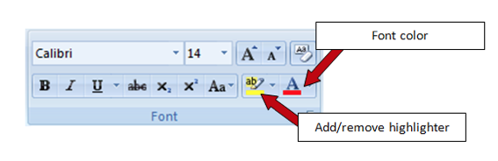

Disclaimer. This sample safety program template cannot be used as is. You must customize the template to meet the needs of your organization. United Fire Group does not guarantee that this template is or can be relied on for compliance with any law or regulation, assurance against preventable losses, or freedom from legal liability. We make no representations or warranties of any kind whatsoever, either express or implied, in connection with the use of this template. United Fire Group will not be liable for your use of the template as customized by you. All safety programs and policies, including this template and the information you supply to complete it, should be reviewed by your legal counsel and/or risk management staff.

DISTRACTED DRIVING POLICY
To improve employee safety and eliminate unnecessary risks while operating a vehicle,
has enacted a distracted driving policy, effective .
is committed to ending the epidemic of distracted driving and have developed the following policy which applies to any employee operating a company vehicle or a personal vehicle used for company business.
The policy applies to company issued cell phones, personally owned cell phones, hands free devices, and similar electronic devices.
- Cell phone and Bluetooth® devices must remain off while the vehicle is moving.
- Incoming calls should go directly to voicemail while the vehicle is moving.
- If you must place or receive a call, pull off the road to a safe location and stop the vehicle before using your phone.
- A passenger in the vehicle may place or receive a call while the vehicle is moving.
- Inform regular callers of the best time to reach you based upon your driving schedule.
- Modify voice mail greetings to indicate that you are unavailable to answer calls or return messages while driving.
- Under no circumstances is texting while driving allowed.
I acknowledge that I have received a written copy of the distracted driving policy. I fully understand the terms of this policy, agree to abide by these terms and will accept the consequences of failing to follow the policy.

Employee Signature Date

Employee Name (printed)

