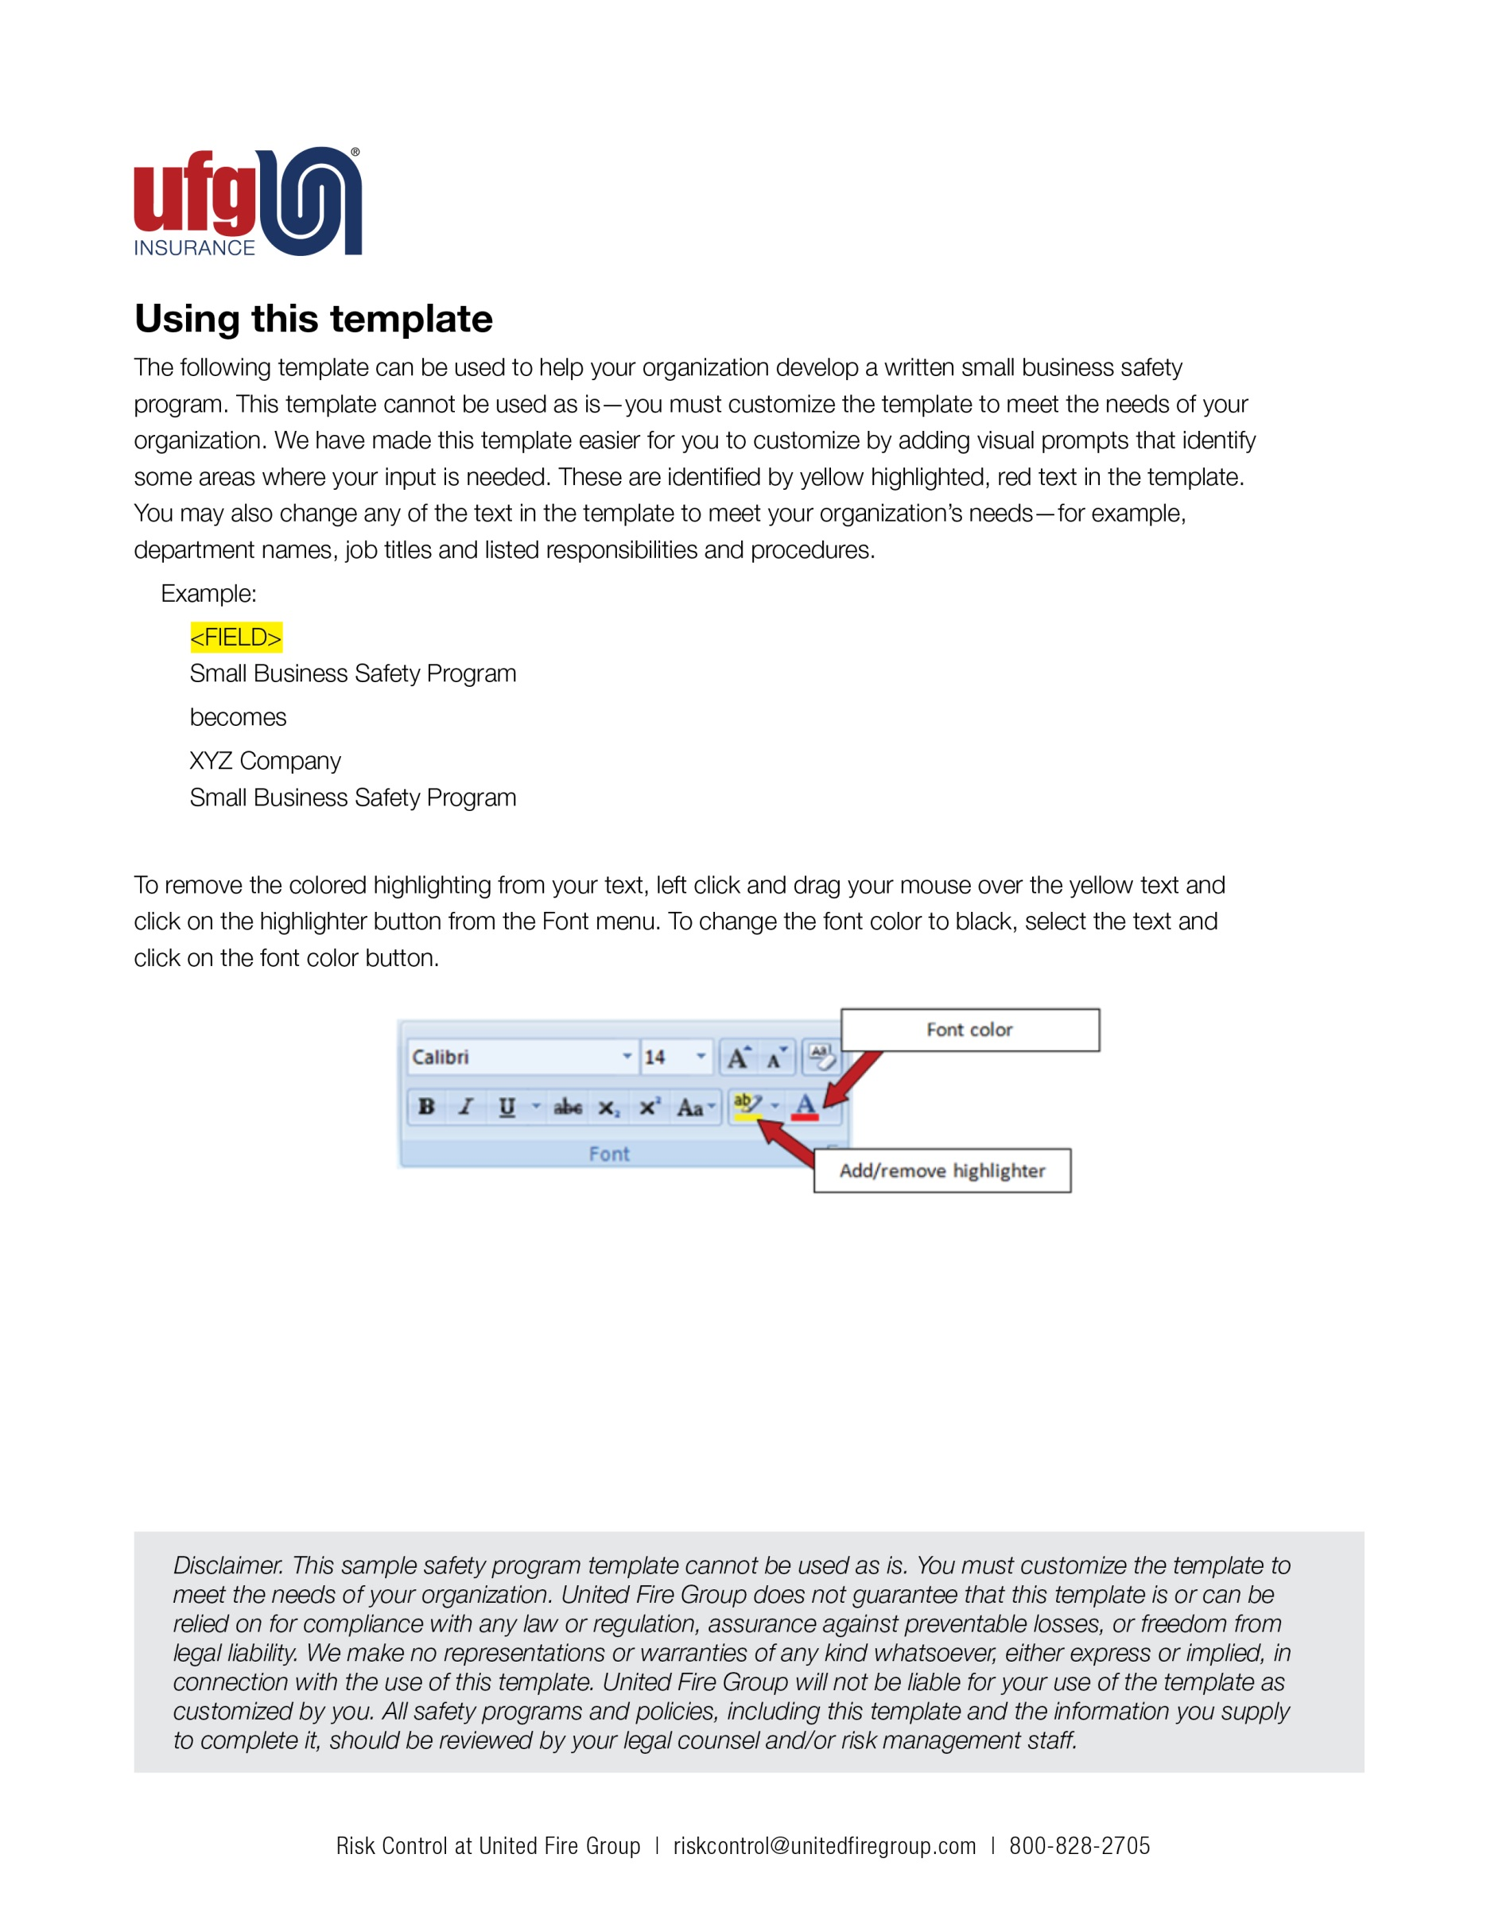

Introduction

Members of the State LICA program have varied construction operations and potential exposures which could lead to losses or claims, if not controlled. The type of work completed by contractors varies from small agricultural operations completing field tile and terracing of fields to large excavation and utility contractors. Anticipated loss exposures are employee injury, liability claims, automobile accidents and equipment damage, vandalism or theft.

Operations completed for members can include the following:

- Grading of land - includes site preparation for building construction or street and road building. Other operations can be clearing of brush, field terracing and general movement of dirt at the customer’s request and plans.
- Agricultural – includes irrigation system excavation for underground piping and field tile installation other drainage related work
- Excavation work – includes digging of foundations, ponds, ditch clearing and excavation and utility work such as water and sewer for local municipalities and site utilities for subdivisions
- Dump truck hauling of materials for the jobsite & truck/lowboy operations for moving their own equipment
- Other work completed may include snow removal, small building demolition, sidewalk and parking lot maintenance and paving.

The list of possible operations above is not all inclusive but a good representation of the type of work that will be encountered. Programs and controls for potential loss exposures which may be encountered due to daily operations are provided within this document. By following strict rules and regulations established by OSHA and your company, the identification of key employees as well as competent persons and implementation of the included guidelines, this potential can be reduced.

United Fire Group Risk Control Consultants are available to assist you in establishing desired programs and provide training as required.

<Company Logo Image Here>

<Company Name>
Small Business Risk Management Program
Date
STATEMENT OF SAFETY POLICY
Safety is everyone's responsibility. It is the desire of <Company Name> to help provide a safe working environment for all employees.
To accomplish this, management will provide reasonable safeguards to help insure safe working conditions and support the safe and efficient development of all work activities.
The need also exists for recognizing that no job is so important that we cannot take time to perform our work safely.
Our employees are our most important assets. We are serious about safety and health and keeping you gainfully employed here at <Company Name>.
Employees are expected to use the safety equipment provided. Rules of conduct and rules of safety shall be observed. Safety equipment shall not be destroyed or abused.
The joint cooperation of employees and management in observance of this policy will help provide safe working conditions, help reduce work related accidents and will be to the mutual advantage of all. Therefore, we ask your cooperation and support to help make all our jobs safe.
It is our policy at <Company Name> to ensure a healthy workplace for all employees. We have implemented the following safety and health program. Managers, supervisors and employees are all responsible for implementing this program. We have committed resources to ensure safety on our job sites. Our goal is to reduce the number of accidents and injuries, and that requires cooperation in all safety and health matters between employees, their fellow workers and management. Only through this cooperative effort can we establish and maintain an excellent safety record.
Employees are responsible for cooperation with all aspects of this safety and health program, including compliance with all rules and regulations for continuously practicing safety while on the job. The safety director, project managers, superintendents and supervisors have our full support in enforcing the provisions of this policy.
<Safety Director Name> is our safety director and reports to the president. All supervisors and liaisons will report safety concerns to the director. The site supervisors are responsible for safety and health at each worksite. Each site supervisor will choose an employee to act as the safety and health liaison for that site. Employees will report all safety and health concerns to their supervisors. The safety director will set up training programs and provide the necessary personal protective equipment (PPE).

Management will set accountability measures for meeting safety and health responsibilities.
Safety will be planned into each site. Each site is unique. An initial site safety inspection checklist will be used prior to starting work and adjusted for the specific location and job. The site checklist will be revised as the site changes. Supervisors will inspect each area of the worksite daily using the revised checklist. The safety director will make random site inspections and review the results with management.
Each employee will be trained about safety and health at the time of hire, at the start of each job and as needed.
Safety meetings will be scheduled at least monthly, with safety topics chosen by the safety director. Attendance is mandatory at all safety meetings. Toolbox meetings and other on-site safety meetings will be arranged by the supervisor weekly or as needed. Safety suggestions and safety audits will be reviewed at that time.
<Employee Name> will investigate all accidents and near-miss events. The site supervisor will write the accident report with assistance from the liaison. The written reports will note corrective or preventive action taken. Training or retraining will be done as needed.
The safety director will review all accident and near-miss reports, supervisor and site audits, and this program, and will make recommendations to management about how to improve <Company Name>’s safety and health efforts on an annual basis.
Safety is a very important part of our overall company program. A violation of our safety and health rules will be treated with the same disciplinary action as our other policies described in our company handbook under "disciplinary actions" (i.e., drug abuse, absenteeism or tardiness).

Management responsibilities
- Provide means to accomplish policy as stated above.
- Endorse this policy and discharge any employee willfully disregarding it.
- Establish and provide safety training for personnel, both for new employees and present employees.
- Periodically audit and review the safety records and reporting functions.
- Encourage, endorse, promote, and attend safety functions.
- Maintain open lines of communication between employees, supervisors and management relative to the free exchange of safety suggestions and information.
- Establish safety goals and objectives and the tactics by which they may be achieved.
- Monitor the follow-up on recommendations made to improve performance, control losses, and prevent accidents.
- Personal protective equipment (PPE) shall be made available to all employees. Each job should be reviewed prior to work starting to determine appropriate PPE to be provided. All employees should receive training in proper use of PPE.
- Establish a Risk Transfer Policy for all subcontractors
Superintendent, foreman and supervisor responsibilities
- Be completely responsible for on-site safety.
- Orient new employees in safe job procedures, job assignments, job requirements, and all rules and regulations that they will be expected to observe.
- Report any unsafe conditions or equipment and follow up to insure that any defective equipment or unsafe conditions are corrected.
- Review the daily activities of each employee and assist the enforcing of the safety program and the observance of all safety rules.
- Maintain satisfactory standards of housekeeping throughout the jobsite.
- Know how to operate all emergency equipment in their area of responsibility.
- Enforce the wearing of required personal protective equipment.
- See that all injuries are cared for properly and reported promptly.
- Investigate all accidents, file complete reports and correct the causes immediately.
- Re-train or instruct workers involved in accidents and those workers whose performance or actions make additional training necessary.
- Be familiar with the laws pertaining to safety and its basic requirements.
- Perform job hazard analysis by established methods and file reports in a timely manner.

Responsibilities of all employees
Safety is a management responsibility. However, management cannot be solely responsible for the acts of employees. You are expected, as a condition of employment, to work in a manner, which will not inflict self-injury or cause injury to your fellow workers. It is important that you understand that responsibility for your own safety is an integral job requirement. Each employee will:
- Comply with all safety rules and regulations and participate in safety training. Follow the established safe job procedures. You are to perform only those jobs you have been assigned and properly instructed to perform.
- Wear the protective equipment required for your job as established by your supervisor. It is your responsibility to see that protective equipment should be in good repair. Damaged equipment should be reported to your supervisor immediately.
- Refrain from any unsafe act that might endanger you or your co-workers.
- Use the proper tools for the job.
Help maintain a safe and clean work area.
- Report all unsafe conditions and accidents to your supervisor immediately whether anyone is hurt or not. In cases of injury, get first aid as soon as possible. In all cases a written report of injury will be completed.
- First aid will be administered only by the first aid department or specifically authorized personnel. Under no circumstances shall any employee attempt to remove foreign objects from the eyes or ears of a fellow employee.
- Know what emergency telephone number to call in case of fire and/or personal injury.
- Keep all mechanical safeguards in position during operation. Put main switch in “off” position whenever making adjustments, when setting up jobs or when machine is to remain idle for any length of time. Don’t allow machinery to operate unattended.
- Use only the machinery, equipment and tools you are qualified and authorized to use by the supervisor.
- Do not use or possess intoxicating beverages or substances on the job.
- Refuse to engage in horseplay on the job. Horseplay, such as scuffling, practical jokes, or throwing articles at each other will not be tolerated.
- Help extend the life of equipment through proper operation and avoidance of abuse.
- Exhibit safe worker habits off the job, as well as on.
- Report defective equipment, machinery, hazardous conditions or unsafe practices to your foreman or supervisor immediately.
- Caution all other employees who might be endangered by the work you are doing.
- Consult with your foreman before altering safety rules. Ignorance of safety rules will not be accepted as an excuse.
- Do not make repairs on any electrical device or equipment unless authorized to do so. Electrical equipment is not to be tampered with in any way. The covers on switch boxes and fuse stations are to be kept closed at all times.
- Do not remove any guard installed over the point of operation, power transmission, or moving parts without permission from your supervisor and then only after proper safety procedures have been followed.
- Never use compressed air for cleaning clothes, cooling or practical jokes. Violation of this rule can result in serious injury or death.
- Do not use flammable solvents in an open container. Flammables must be stored and handled in approved safety containers.
- Do not block fire extinguishers, sprinklers or fire exits by supplies, stock or parts at any time.
- Riding hand trucks and hitching rides on forklifts is prohibited.
- Do not stand or walk under suspended loads.
- Do not repair machinery or equipment unless you are qualified to do so and authorized by your supervisor.
- Tag or lock open machine master switches when major repair, oiling and greasing or maintenance is being performed.
- Walk—don’t run—while you are within the work area.
- Do not use your cell phone while driving company vehicles.
Employees who violate these safety guidelines may be subject to disciplinary action.

Line of Business - Related
Risk Management Controls

Workers’ Compensation Exposures and Controls

The type of Workers’ Compensation claims anticipated are numerous and varied. Controls should include but are not limited to:

Manual Material Handling

- Strains from lifting can be avoided by pre job planning for lifting to be completed
- Use of mechanical handling equipment/machinery to reduce lifting stresses
- Two man lifts for materials and weights over 75 pounds
- Training on load rigging and securing for all employees
- Screening of employees to determine fitness for work to be completed
- Gloves should be worn when handling materials and tools as needed

Struck By Accidents

- Equipment on the job site are to have operational back up alarms
- Employees should wear reflective vests in areas of equipment or vehicle traffic
- Hard hats should be worn when equipment and work from above is encountered
- Safety glasses should be worn when power equipment or tools are used
- Equipment lifting and movement of material into the work zone should be done only when hand signals are provided by employees receiving/installing the material
- Trenching – if completed competent persons should be identified and all employees trained in potential exposures

Slip, Trips and Falls

- Equipment steps and handholds should be maintained so that 3 point contact can be maintained when climbing on and off
- Job site housekeeping should be maintained
- Proper foot wear should be required
- Ladders if used in trenches should be in good maintenance
- If night work is completed, proper lighting should be provided

Liability Exposures and Controls

The type of liability claims anticipated are property damage from work completed by the contractor or their subcontractors to possible injuries to the general public. Controls should include but are not limited to:

Underground Utility Strikes

- 1-800 call numbers for utility locates should be used prior to any excavation with no excavation started until all lines are located and marked
- Hand locating or potholing of underground lines should be completed
- Photos of mismarked lines should be taken if struck
- Emergency procedures established for utility strikes and all employees trained

Public Access to Work Zones

- Access to the job site should be secured with signs, barricades or fence
- Visitors on site should be required to wear proper safety equipment
- Excavations should be closed at night and if unable to then proper barricades should be provided

Vehicle/Equipment Operations

- Backing should be completed with directions of employees on site
- Back up alarms on equipment should be maintained and operational
- Equipment properly secured to equipment when moved
- Bridge/overpass heights on path of travel when hauling equipment should be previewed
- Pre-job planning and review of overhead lines in work zone

Subcontractors and Risk Transfer

- All subcontractors should be required to provide certificates of insurance with limits equal to the contractor
- The LICA contractor should be named as additional insured with completed operations on the subcontractor policy
- Contracts signed by the LICA contractor should be reviewed by legal counsel

Automobile Exposures and Controls

The type of vehicle claims anticipated are rear end accidents, backing into buildings, vehicles or equipment, vehicles leaving the road and objects that may fall off vehicles. Controls should include but are not limited to:

- Motor Vehicle Records of all drivers should be reviewed at hire and at least once annually
- Drug testing programs are recommended for all drivers but required for all drivers of regulated vehicles and follow requirements of the Federal Motor Carrier Safety Regulations (FMCSR)
- Routine and scheduled vehicle maintenance with records on file
- Regular inspections of vehicles should be completed by drivers to ensure maintained in top operating condition
- Backing should be completed with other employee direction and back up alarms installed on heavy vehicles and maintained in operable condition
- Material or equipment should be properly secured and trailers cleaned of loose debris
- Seat belt enforcement should be in place
- Cell phone use should be prohibited while operating all motor vehicles
- No unauthorized passengers should be allowed in vehicles

Inland Marine Exposures and Controls

The type of Inland Marine claims anticipated are equipment damage due to a variety of causes. Controls should include but are not limited to:

- Equipment should be routinely inspected and maintained at regular intervals with records on file
- Equipment should be secured at the end of each work day and keys removed
- Equipment should be parked on high ground at the end of the work day if the work zone is in a possible flood plain
- Small loaders should be blocked by larger equipment as possible to reduce theft potential
- Only trained and authorized operators should be allowed on equipment
- Equipment should not be leased or loaned to others
- Hired haulers should be required to provide proof of insurance and where possible name the contractor as an additional insured

Disciplinary procedures
<Company Name> believes that a safety and health program is unenforceable without some type of disciplinary policy. Our company believes that in order to maintain a safe and healthful workplace, the employees must be cognizant and aware of all company, state and federal safety and health regulations as they apply to the specific job duties required. The following disciplinary policy is in effect and will be applied to all safety and health violations.
The following steps will be followed unless the seriousness of the violation would dictate going directly to Step 2 or Step 3.
- A first violation will be discussed orally between company supervision and the employee. This will be done as soon as possible.
- A second violation will be followed up in written form and a copy of this written documentation will be entered into the employee’s personnel folder. Time off without pay (three-day minimum).
- A third violation will result in termination.
If an employee of this company knowingly and willingly violates any of the safety rules or procedures, or puts his/her self in an imminent danger situation, the employee will be immediately discharged.

<Company Name>
<Address>
<City, State>
Phone:<Phone> Email: <Email>
Employee acknowledgement
I have read and understand the safety program and safety rules of <Company Name>. I understand it is my responsibility to act responsibly and work in a safe manner. I will report immediately any unsafe conditions, unsafe actions, injuries or any near-miss accidents. I will notify my supervisor of these situations and if any questions arise.
It is my responsibility to use safety equipment and follow safety practices as defined in the safety program or by regulation.
I understand work tasks and conditions on a jobsite change and I should not be complacent about any hazards on the job and act immediately to eliminate them. I will help my fellow employees and discuss safety if I see any unsafe actions. I will be open to and accept suggestions on safety. I will work to help foster a work environment with good, open and honest communication and teamwork.
All employees, including myself, have the right to a safety and healthy work place. No one should accept an unsafe condition and or practice.
No job is so important that we cannot take time to perform our work safely.
Employee signature__________________________________________

Supervisor signature_________________________________________
Date___________________________
(Remove and place in employee file.)

