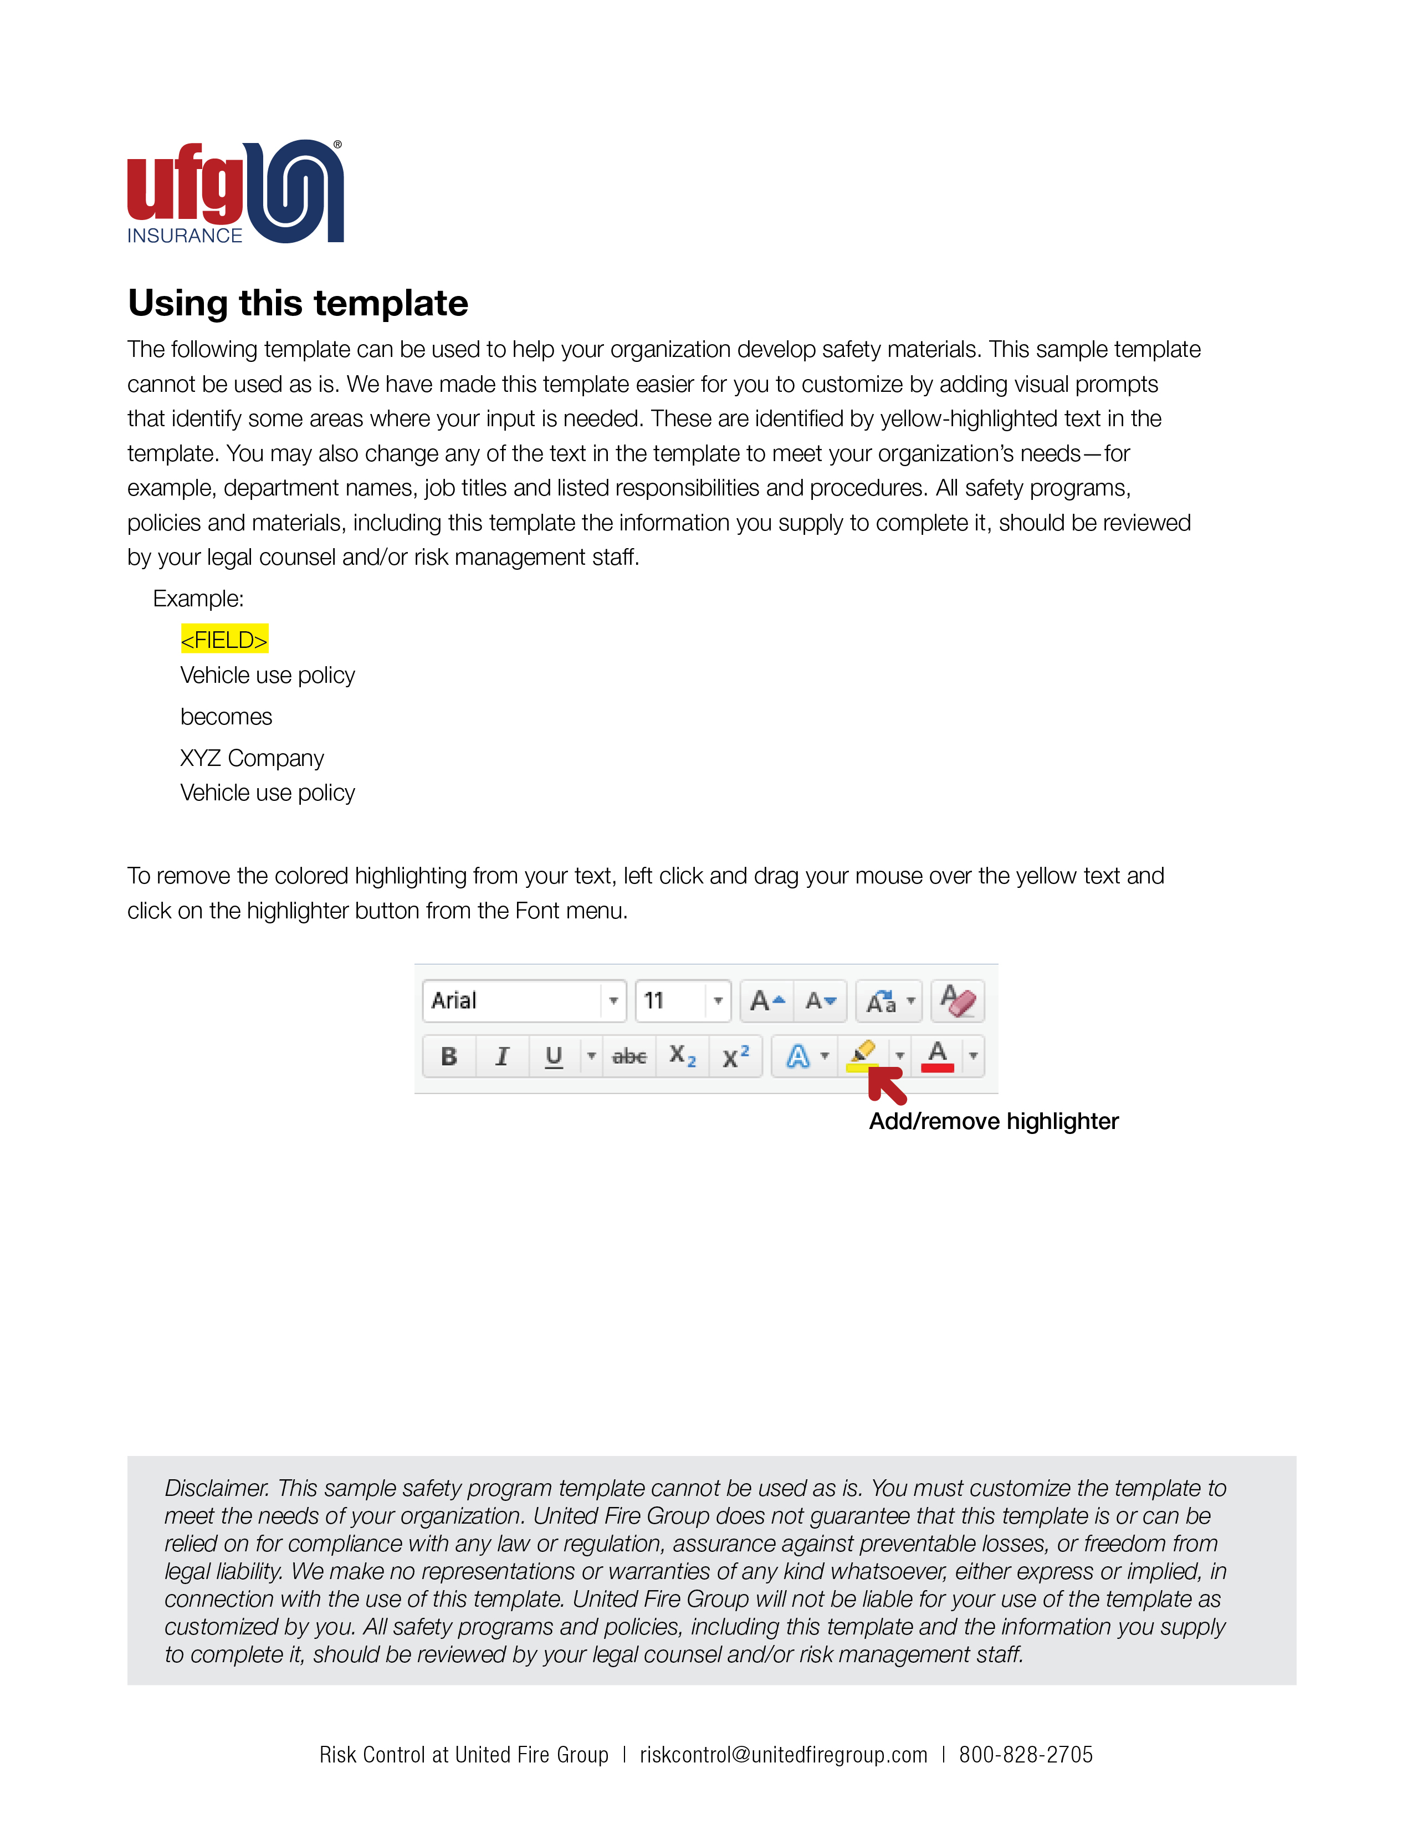

<Company Logo Image Here>

<Company Name>
Distracted driving policy
Date

To improve employee safety and eliminate unnecessary risks while operating a vehicle,
has enacted a distracted driving policy, effective .
is committed to ending the epidemic of distracted driving and have developed the following policy which applies to any employee operating a company vehicle or a personal vehicle used for company business.
The policy applies to company issued cell phones, personally owned cell phones, hands free devices, and similar electronic devices.
- Cell phone and Bluetooth® devices must remain off while the vehicle is moving.
- Incoming calls should go directly to voicemail while the vehicle is moving.
- If you must place or receive a call, pull off the road to a safe location and stop the vehicle before using your phone.
- A passenger in the vehicle may place or receive a call while the vehicle is moving.
- Inform regular callers of the best time to reach you based upon your driving schedule.
- Modify voice mail greetings to indicate that you are unavailable to answer calls or return messages while driving.
- Under no circumstances is texting while driving allowed.
I acknowledge that I have received a written copy of the distracted driving policy. I fully understand the terms of this policy, agree to abide by these terms and will accept the consequences of failing to follow the policy.

Employee Signature Date

Employee Name (printed)

