#### **Daily Toolbox Talk: Plan with Precision**

#### **Monday, May 5, 2025**

**Plan with Precision**

You take pride in your work and even greater pride in the incredible things we accomplish as a team. High-performing teams start every day and operation with a strong plan, a plan that considers every aspect of every task up front, so we’re able to anticipate challenges, prepare for the unexpected and overcome potential hazards. The earlier a task can be planned the more opportunities there are to develop the most effective risk controls.

**Focus on High Risk**

The project team must proactively identify and capture high-risk activities through detailed scheduling look-ahead. This approach allows for early detection of potential hazards and the implementation of appropriate control measures. Your team might utilize scheduling software or utilize a three week look ahead that is completed in the field. Regardless of how your employer conducts scheduling, we as an industry need to start to identify High Risk Activities so we can adequately plan for the risks associated with them. Identifying these items helps teams focus on activities that could potentially lead to Significant Incidents or Fatalities (SIF).

**Collaborative Planning with Trade Partners, Individual Workers & Subject Matter Experts**

Safety planning should not be the sole responsibility of individual workers left up to the Pre-Task-Planning process that occurs in the work location before the start of work daily. The project team must work closely with trade contractors, partners, and subject matter experts to develop comprehensive risk mitigation plans. This collaborative effort ensures that all parties are aware of the risks and the necessary controls to mitigate them. Effective planning greatly reduces the reliance on our workforce to identify the hazards and utilize controls to eliminate the opportunity for an incident to occur.

An example of this would be a worker who must utilize a ladder to gain access to overhead work. Through proper planning and utilizing the hierarchy of controls it may have been possible to complete the work off site in the shop and lifted into place on site. The team may have rented a scissor lift for the employee to gain better access to the overhead work, however if all the decisions are left to the worker in the field, we are missing opportunities to identify risk and eliminate or reduce it before we ask a trade worker to perform their duties.

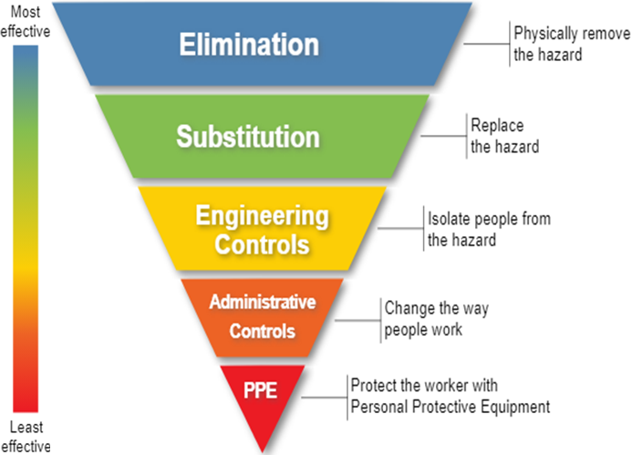

**Utilizing the Hierarchy of Risk Control**

All parties involved in planning work should utilize the hierarchy of risk control to manage hazards effectively. It is essential to review how employees plan their work using the hierarchy of risk control. This review ensures that the most effective control measures are being implemented and that workers are adequately protected from potential hazards.

This hierarchy includes:

**Elimination:** Removing the hazard entirely.

**Substitution:** Replacing the hazard with a less dangerous option.

**Engineering Controls:** Isolating people from the hazard.

**Administrative Controls:** Changing the way people work.

**Personal Protective Equipment (PPE):** Using protective gear to reduce exposure to the hazard.

**Plan with Precision Summary:**

**Plan with Precision** emphasizes the importance of meticulous planning in high-performing teams. By considering every aspect of a task upfront, teams can anticipate challenges, prepare for the unexpected, and overcome potential hazards. Early planning allows for the development of effective risk controls.

**Focus on High Risk:** Proactively identifying high-risk activities through detailed scheduling helps in early detection of hazards and implementation of control measures. This approach is crucial for preventing Significant Incidents or Fatalities (SIF).

**Collaborative Planning:** Safety planning should involve trade partners, individual workers, and subject matter experts. This collaboration ensures comprehensive risk mitigation and reduces reliance on workers to identify hazards on their own.

**Utilizing the Hierarchy of Risk Control:** Effective hazard management involves using the hierarchy of risk control, which includes elimination, substitution, engineering controls, administrative controls, and personal protective equipment (PPE).

**Energy Source:** The Energy Wheel is a tool that helps workers identify potential hazards from ten common energy sources, such as gravity, motion, mechanical, electrical, pressure, chemical, radiation, thermal, sound, and biological. This tool is used during safety briefings and hazard assessments to ensure thorough risk evaluation.